INSTRUCTION MANUAL
2L/3.6L/4L/5L/8L/10L Mini Keg with straight Spear Tap co2
Regulator System
Before using the Mini Keg Tap System,become familiar
with the various parts.Wash the spear valve, mini keg,
faucet, silicone tubes in warm, soapy water.Rinse and dry
thoroughly.
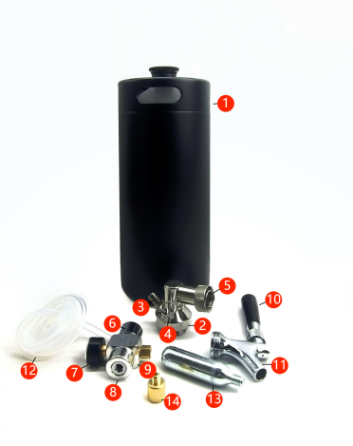
①Mini keg Growler 2L/3.6L/4L/5L/8L/10L
②SS Straight Spear Valve
③Gas-In Connection Port
④Pressure Release Valve 30PSI
⑤cross-Bar
⑥co2 Regulator Knob
⑦30PSl Pressure Gauge
⑧Regulator Base
⑨Aluminium co2 Regulator Body
⑩Black Plastic Tap Handle
⑪chrome Plated Faucet Body
⑫silicone Beer Hose
⑬16g Threaded co2 cartridge/Capsule(Not Included)
Thread:3/8""-24 UNF
⑭ Copper swivel joint
PART ONE:HOW TO ASSEMBLY
- Fill mini keg at your favourite craft breweries or with
your own home brew beer.
- cut beer hose according to keg height and attach onto
barbed fitting of spear valve, make sure hose can touch
bottom of keg without overlong or over short.
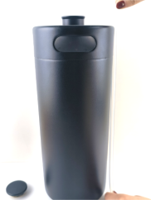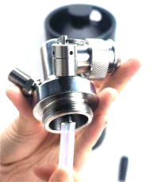
- Insert spear valve into keg and screw on until tight.

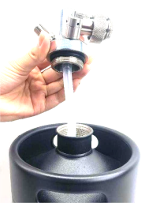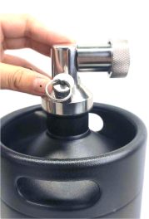
4.Check whether the regulator knob is in OFF position
(Decrease). If not, please follow arrow mark instruction
to turn the regulator knob counter-clockwise to off position.
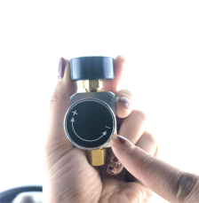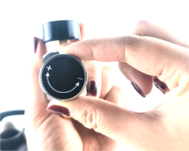
5.Turn in a new 16g co2 capsule with thread type of 3/8-24UNF, turn clockwise firmly into the regulator base.

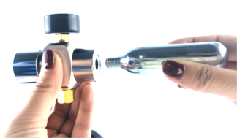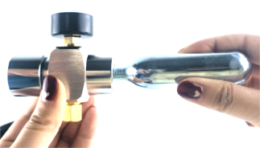

REMARK: DON'T stop turning if you hear a slight gas leak
swish, finish turning it in all the way it seal properly.
- Tighten the copper adapter, then Connect the regulator with capsule to the spear valve gas-in port .
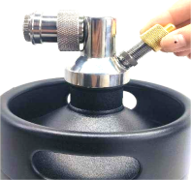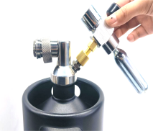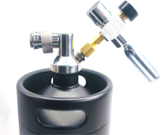

- Install faucet onto spear valve cross-bar, make sure
the connection is proper and tight.
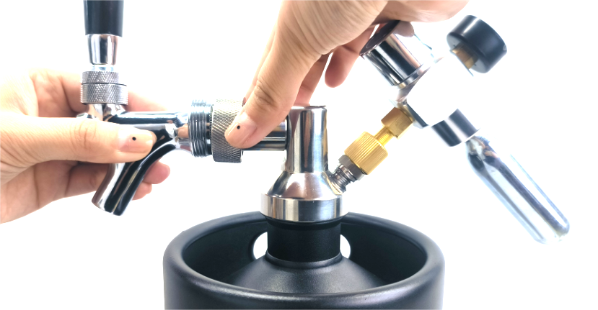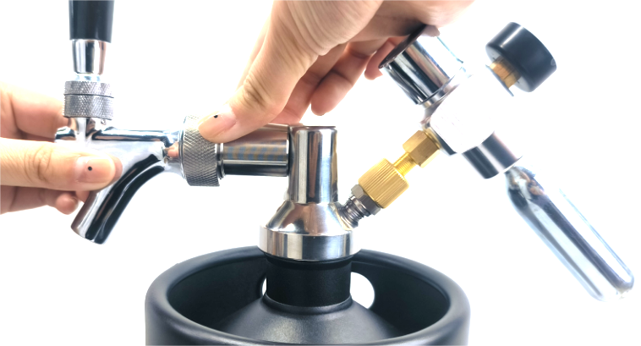
REMARK: Improper combination would cause leakage of beer.
- Pull on pressure release valve ring for a couple
of seconds, if the keg was shaken in transit or warmed,
it may contain excessive pressure which must be relieved before tapping.A hissing noise is expected.

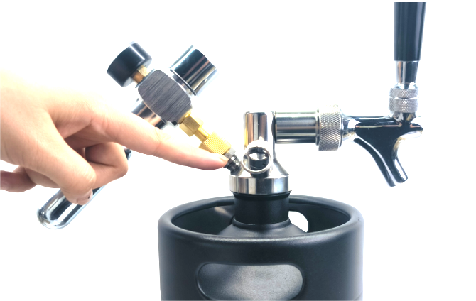
- Slowly turn the regulator
knob in clockwise direction to3-5 PSI, and stop for 2
seconds ad turn off
regulator. Wait for 2mins ,then pull on the
pressure release valve ring
fora couple of seconds.This
is for adjusting pressure of keg beer.
- Put a glass or pitcher under the faucet spout, with the
faucet knob pulled forward(ON), slowly turn the
regulator knob in clockwise direction, until beer starts to
flow out.
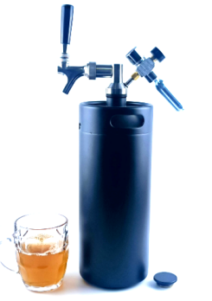
REMARK: Don't continue adding pressure, suggest
tapping 5-8 PSI(Max pressure 25PSI), so please stop
turning the regulator knob when the pressure is enough
to tap beer out with perfect foam.Too much pressure
would cause over foam. When the beer stopped or flow
slower, try turning the regulator knob on slowly, to get
bigger pressure.
- when you finish tapping,please turn regulator knob
to OFF position.
- If no beer flow out, then the co2 capsule needs to be
replaced, unless no beer is remained(Normally, 16g
capsule can tap 4-5 liters of beer).
caution: Removing a punctured capsule from regulator should be done slowly.Swish is expected if pressure remains.
- Turn the regulator knob off and install a new capsule
into the regulator by following above steps.
PART TWO: TROUBLE SHOOTING GUIDE
1.Faucet Leakage:
Solution: please screw out and remove the faucet, and
install again, make sure the faucet can match the
connection of spear valve cross-bar tightly.

2.Too much Foam:
Solution: Turn off the regulator and pull the pressure
release valve ring to release the pressure.And turn on
the regulator again and adjust to 3-5psi.
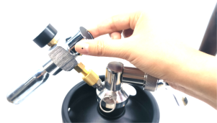

3.Leakage of co2:
Co2 capsule should be installed properly and tightly. In
case there is co2 leakage,please observe the position of
leakage and continue with the tightening process, but
never screw out if gas remains.

PART THREE: IMPORTANTSAFETYINFORMATION

To reduce the risk of personal injury or property damage
when using this appliance, basic safety precautions
should always be observed, including the following:
1.Keep away from children under 18.
2.Never point cylinder towards someone's face.
3.Do not heat over140°F as rupture may occur!
4.Discontinue using of this equipment if unsolvable
leakage or visible damage is found.
5.Capsule end become punctured when turned into
regulator base.Unscrewing before it's empty can result in loss of high pressure gas.Please remember, never unscrew the co2 capsule before gas used up, liquid co2 spray onto unprotected skin may cause freezing burns.
6.Exterior of capsule may become frozen when in use,
this is normal.But don't touch with bare hands, your
fingers could stick to the frozen surface and cause
frostbite.
7.Please ship via land or sea shipment, never bring co2
capsule when you travel by air.

