User Manual
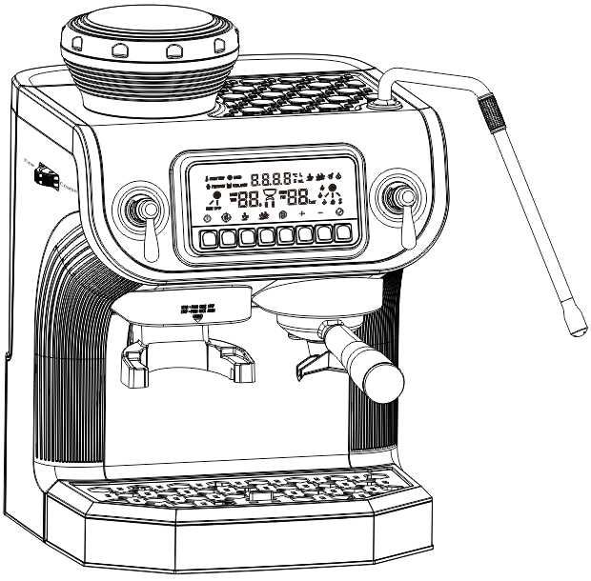
Model: ST-530ET

(The product in the package shall prevail.)

Dear users, please read this manual carefully to ensure correct operation before using the product. This product is only suitable for sales and use in mainland China.
Company name: Foshan Shunde Stelang Electric Appliance Co., Ltd.
Address for after-sale service: Nanpu Industrial Area, Junhe Road, Junan Town, Shunde, Foshan, Guangdong, China

Contents
Introduction
Chapter I Precautions for Safe Use
Chapter II Parts Description
Chapter III Description of Control Panel
Chapter IV Directions for Use
Chapter V Descaling Mode
Chapter VI Restore factory setting
Chapter VII Cleaning
Chapter VIII Points for Attention
Chapter IX Solution for Water Pumping Failure
Chapter X Food hygiene label
Chapter XI Product Safety Indexes

Introduction
Thank you for using our company’s coffee maker. We have hereby prepared this manual for you to use and maintain this product properly. Please read this manual carefully before using the product, and keep it in a safe place for future reference.
This manual only applies to ST-530 coffee maker of our company, and our company reserves the right of final interpretation of this manual. All the content in this manual is for reference only for users when using it. For matters not covered, users are welcome to consult our company’s customer service center. Regarding the inadequacies of this manual, users are welcome to put forward their valuable opinions. We hope that our products will bring warmth, convenience and health to your life.

Chapter I Precautions for Safe Use

Read this manual carefully before use, and please pay attention to the following content:
When unplugging the power cord, please make sure that the machine is turned off:
- Avoid the risk of electric shock! Don’t touch the power plug/socket/power supply or the machine with wet hands. Don’t cut off the power by pulling the power cord or the plug.
- Avoid the risk of burns! Don’t move the machine while it is operating.
- Avoid the risk of burns! Don’t touch the hot parts of the machine (such as: water boiling parts or water outlet parts in operation)
- Avoid the risk of burns! Don’t touch steam and water jets.
- Avoid the risk of burns! Don’t open the handle when the machine is operating.
- Avoid the risk of electric shock! Don’t immerse the machine, power cord and plug in water or other liquids.
- Before cleaning or repairing, please make sure to unplug the power cord and let the machine cool down.
- Before connecting the power supply, please check whether the local power supply voltage is consistent with the voltage marked on the product.
- General electrical products are not intended for use by persons with physical, sensory or intellectual disabilities (including children), or persons lacking experience and knowledge, unless they have been supervised or instructed by the person responsible for safety. Adults should instruct children not to play with electrical appliances.
- Don’t let children use this product or play with it as a toy.
- Don’t use the product when the plug, wire or the product itself is damaged. Send it to the maintenance center as soon as possible, and don’t refit, disassemble or repair it by yourself.
- This product is for household use only, and cannot be used for other purposes.
- Please place and use the product on a stable and heat-resistant surface, rather than in a humid and dusty environment. Don’t use it in places with open flames, heat or splashes of water to avoid accidents.
- When the product is in abnormal condition, please stop using it immediately.
- When the product is in operation, please don’t cover the product.
- When the product is in operation, pay attention to water vapor and keep your face away from the water outlet to avoid burns.
- Don’t move the product when it is in operation to avoid accidents.
- When the product is in operation, it will produce slight vibration, causing the coffee cup to move slightly, which is a normal phenomenon.
- Don’t open the handle when the product is in operation.
- Don’t put fingers or other objects into the brewing cup to avoid accidents.
- Keep this product, cords and coffee capsules out of the reach of children.
- It is forbidden to pour hot water into the water tank.
- Don’t unplug the power cord by pulling the power cord.
- Don’t touch the power cord with wet hands.
- Don’t disassemble the product.
- Turn off the product or unplug the power cord before cleaning the product.
- The product cannot be washed directly in water.
- Don’t use it outdoors, and protect the product from heat, direct sunlight, moisture (not immersed in liquid) and sharp edges. Avoid touching the electrical appliance with wet hands, and immediately disconnect the main power supply if the appliance gets wet.
- Regularly check whether the electrical appliance is damaged. If it is damaged, please do not use it.
- If the power cord, plug or other parts are damaged, or the function is invalid, it is strictly prohibited to use the product. Please send it to the service shop for test, maintenance and replacement by professionals.

Chapter II: Parts Description

Parts Description
A | Coffee bean box
B | Coffee powder adjustment knob
C | Control panel
D | Coffee powder outlet
E | Waste water tray
F | Water tank
G | Steam pipe
  G | Name
  A | Steam pipe
  B | Water tank
  C | Water tank cover
  D | Handle
  E | Control panel
  F | Water faucet
  G | Waste capsule box
  H | Waste water tray
H | Handled brewing cup
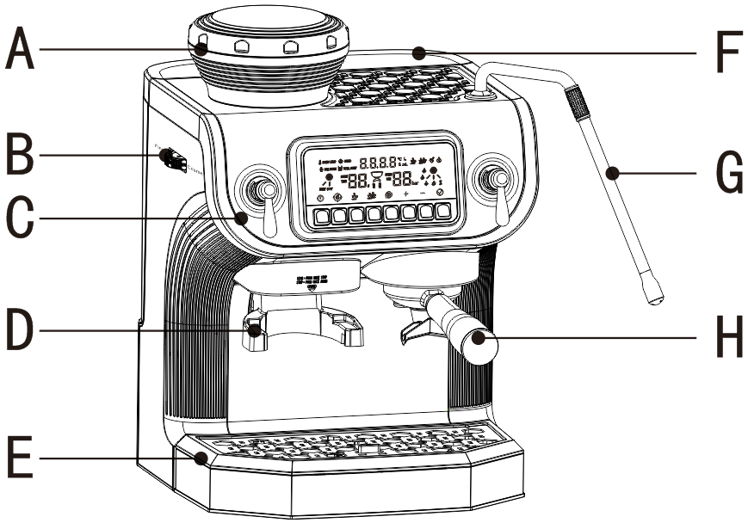

Chapter III: Description of Control Panel

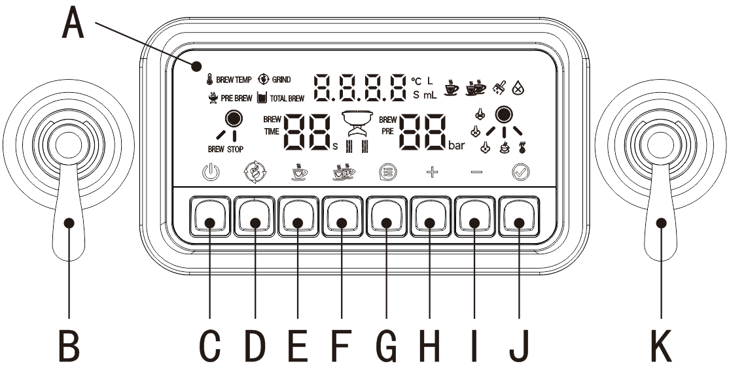
Description of Control Panel
 | Name | Function description |  | Name
A | Display screen | 1. Adjustment of operating parameters of each function  - Display the function status | B | Coffee brewing lever | Toggle the lever to start brewing coffee, and reset the lever to stop brewing
C | Power switch button | Used for turning on or off the machine | D | Grinding key | Press the Grinding key and the machine will start grinding, then press it again and the machine will stop grinding.
E | Single-cup key | Press the Single-cup key to start brewing coffee, and then if you press it again, the machine will stop brewing the coffee. The volume of coffee is a single cup | F | Double-cup key | Press the Double-cup key to start brewing coffee, and then if you press it again, the machine will stop brewing the coffee. The volume of coffee is two cups
G | Menu key | Press the Menu key to adjust the grinding time, extraction water temperature, pre-soaking water volume and time, single-cup coffee water volume, and double-cup coffee water volume | H | “+” key | After pressing the Menu key, adjust the number using the "+" key
I | “-” key | After pressing the Menu key, adjust the number using the "-" key | J | Confirm key | After adjusting the functional parameters, press the "Confirm" key to confirm the setting parameters
K | Hot water / steam lever | Turn the steam pipe to the right to get hot water, and to the left to get steam, and turn it to the left several times to adjust the steam volume. Reset the lever to stop hot water/steam.

Chapter IV: How to Use
The machine must be rinsed when it is used for the first time or if it has not been used for a long time. The rinsing method is as follows:
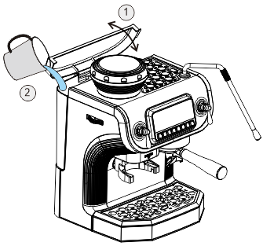



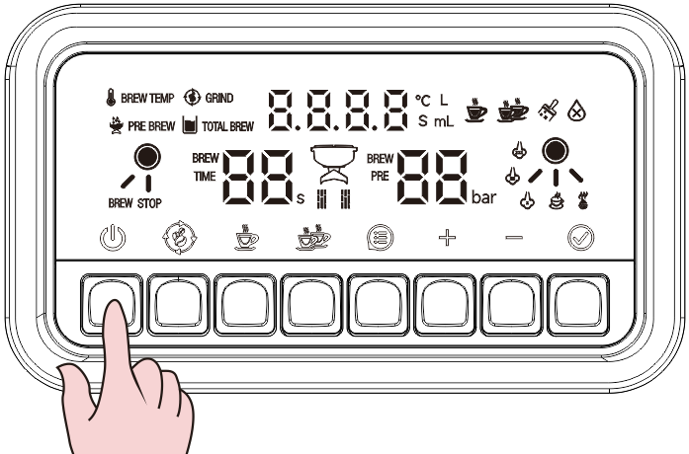
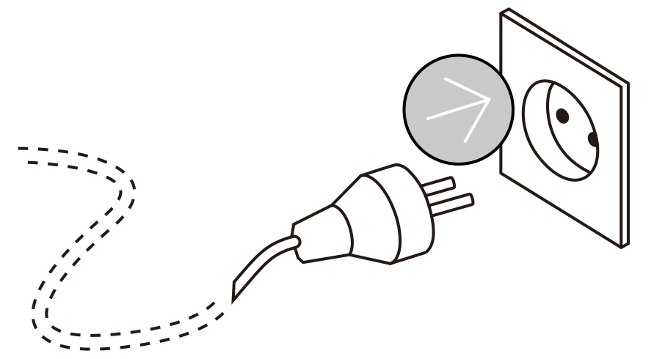

1. Lift the lid of the water tank.
2. Pour no more than 2 liters of pure water into the water tank (water temperature is not higher than 35℃).

Plug in the power

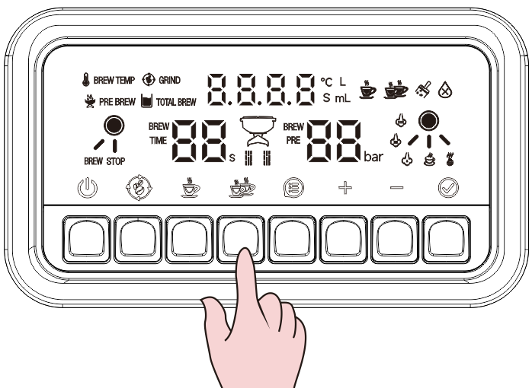
State 1



The water-shortage light flashes, indicating a lack of water in the machine.
Press the single-cup or Double-cup key to fill with water, and the light indicating water shortage will be off. The machine will enter the preheating state.


State 2


The five lights flash, indicating a preheating state.
1. Place a cup with a capacity greater than 150ml above the waste water tray.
2. Press the single-cup or double-cup key and wait for the machine to finish rinsing,

Coffee Bean Grinding
Preparation before putting coffee beans
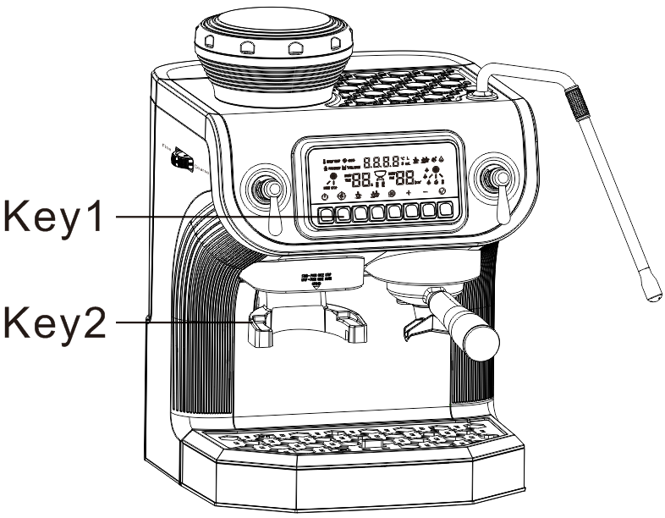
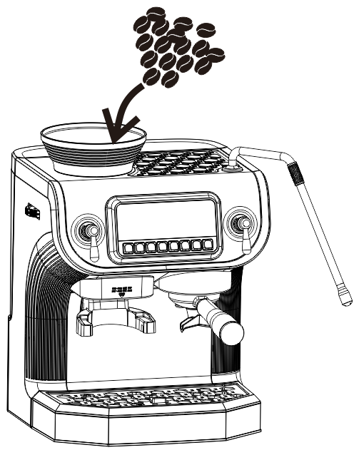
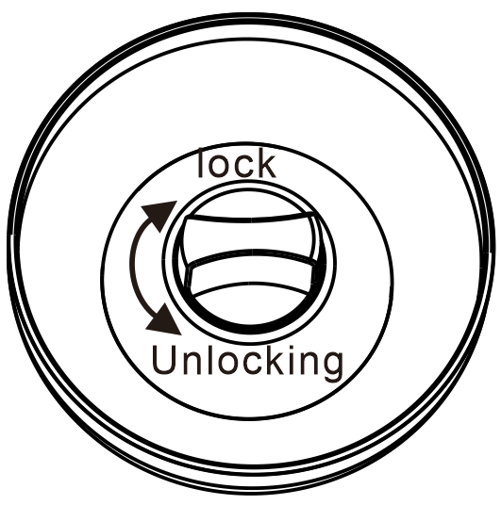



- The light flashes when the bean box is in an unlocked state, and the grinding function does not work.
- The light is on when the bean box is in a locked state, and the grinding function can work.


- Control key 1: Press to start grinding and press again to stop the grinding
- Control key 2: push downward the brewing cup to start grinding, and push the control key 2 downward again to stop grinding.

Make sure the bean box is locked before putting coffee beans.
Pour no more than 150g of coffee beans into the bean box

Method 1
Press to start grinding, until reaching the desired amount of coffee powder, and press again to stop grinding.



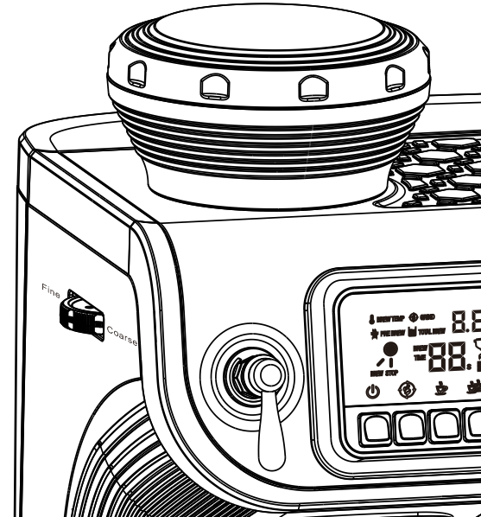

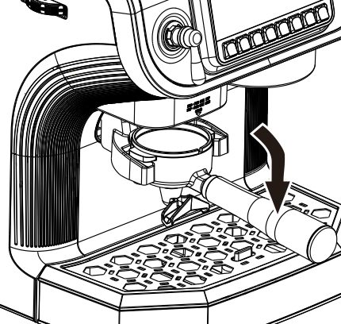
Method 2
Push downward the handled brewing cup to start grinding, until reaching the desired amount of coffee powder, and push downward the handled brewing cup again to stop grinding.

! Attention: 1. After pressing the Grinding key, it will automatically stop grinding after 13 seconds without any operation;
2. You can stop grinding by both pushing downward the handled brewing cup again and pressing the key again.
.

Press to start grinding
Then use the adjusting wheel to adjust and gain the desired coffee powder

Method 1
Press to start grinding, until reaching the desired amount of coffee powder, and pressagain to stop grinding.

Coffee making
Method 2
Push downward the handled brewing cup to start grinding, until reaching the desired amount of coffee powder, and push downward the handled brewing cup again to stop grinding.

! Attention: 1. After pressing the Grinding key, it will automatically stop grinding after 13 seconds without any operation;
2. You can stop grinding by both pushing downward the handled brewing cup again and pressing again.

Adjust to the desired coffee powder
Pour no more than 150g of coffee beans into the bean box

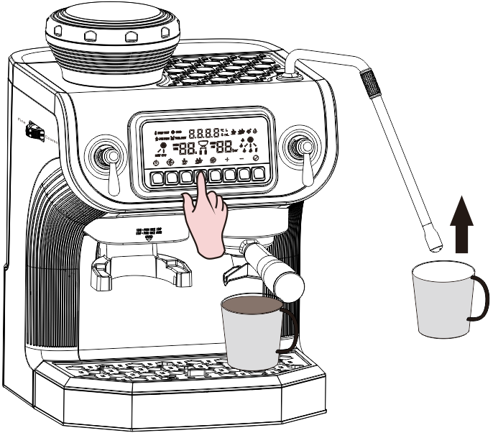
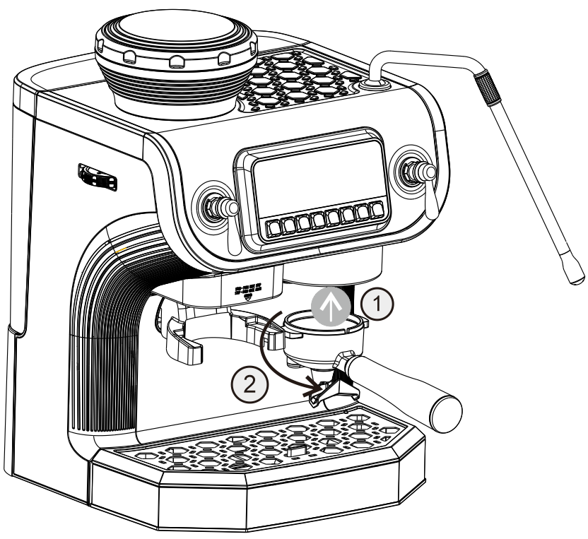
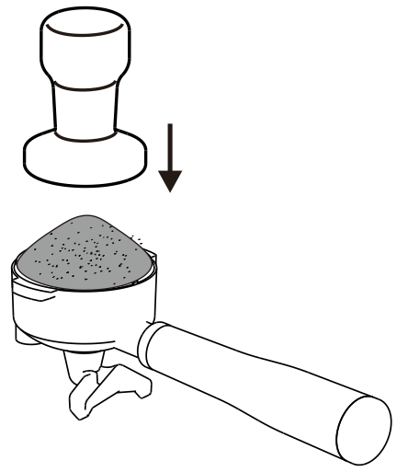
Coffee brewing
1. Place the cup over the waste water tray (make sure there is more than 150 ml of pure water in the water tank)
2. Press the button of the desired coffee amount (single or double cups) until the coffee brewing is finished. (Make sure there is more than 150 ml of pure water in the water tank)
Press down the coffee powder with a coffee spoon

Press down the coffee powder with a coffee spoon

Press down the coffee powder with a coffee spoon

Transferred to handled brewing cup
Press down the coffee powder with a hammer

Preparation of Hot Water
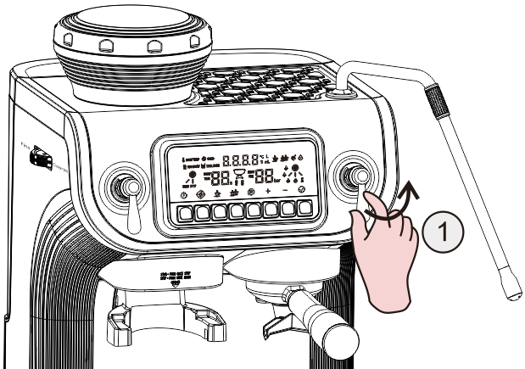
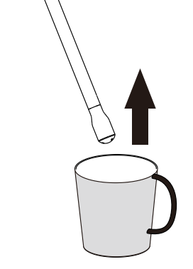

Push the right lever to the right
Put the cup in the steam pipe
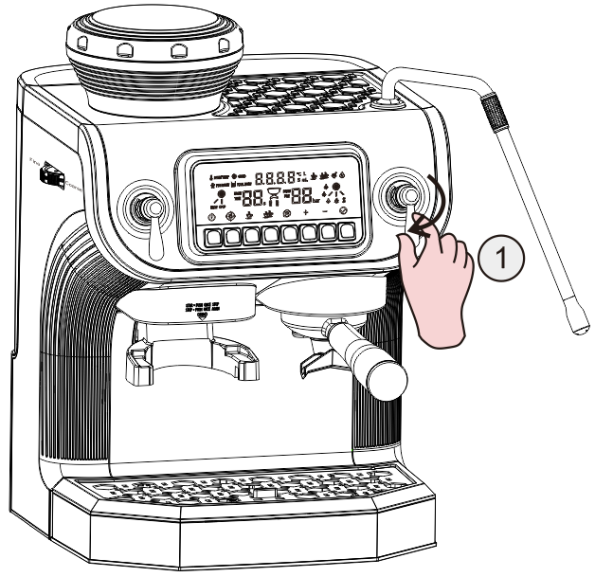

After gaining the desired hot water, reset the lever, and finish the hot water preparation. (Make sure there is more than 150 ml of pure water in the water tank)

Preparation of Milk Foam

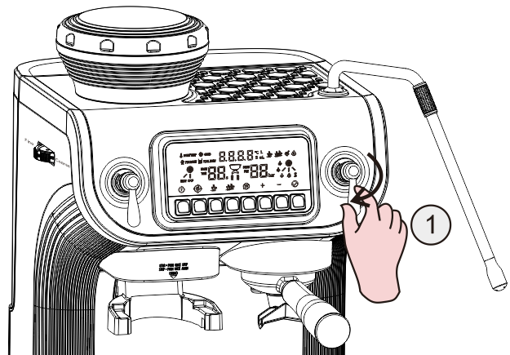
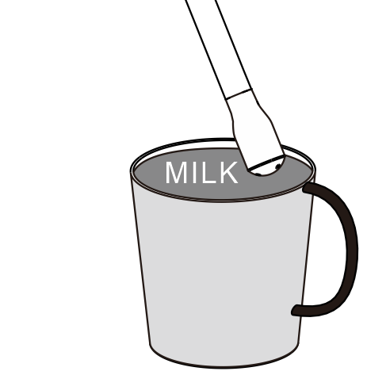
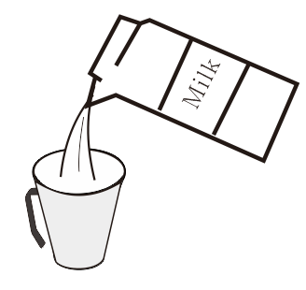
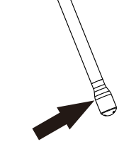

Move the steam rod to 1 to 2 cm from the milk surface and close to the 3 o 'clock position on the right side of the cup, and wait for steam to form
Push the right lever to the left

Pour no less than 50ML fresh pure milk into the cup to ensure that the steam nozzle can be immersed in the milk.

When the steam rod rotates the milk clockwise to form a vortex, slowly lower the cup body. This will bring the steam rod back to the milk surface and start mixing air into the milk. Gently stir the milk level with the steam rod and let the milk rotate at a proper speed.
Place the steam rod at the same level or slightly lower position of the milk surface, and let the milk continue to rotate and generate vortices. Maintain the operation until the milk reaches the required consistency and your hand feels that the cup body is hot and the milk reaches the required temperature (60-65 ° C) That is to say, the milk foam preparation is completed. Press the steam key to stop the milk foam preparation.
Note: Before taking out the steam rod from the milk, press the steam button to stop the milk foam preparation.

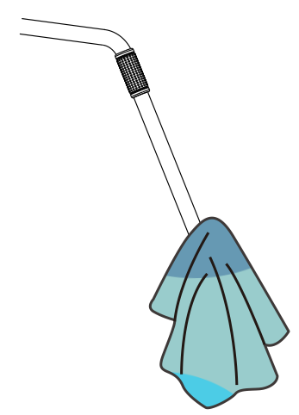
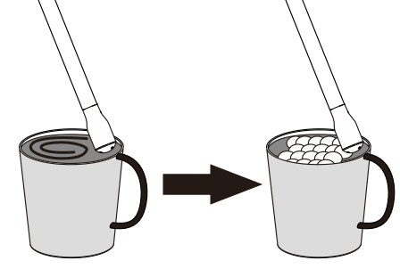

Chapter V: Descaling Mode

Cautions:
As the long-term use of the machine will lead to scale in the internal waterway system of the machine, the machine will show a 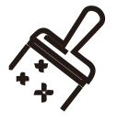 or bad conditions, such as a significant decrease in the amount of coffee or blockage. In this case, it is necessary to use the descaling mode for descaling.

Descaling mode function
1. Put a cup at the coffee outlet and steam outlet of the machine.
2. Fill the water tank with about 1 liter of purified water and put in an appropriate amount of descaling agent.
3. Press and hold the  and  keys for 3 seconds.
4. Press the and then to activate the descaling function. After about 200 seconds, the descaling function will automatically exit and the cleaning lamp will go out

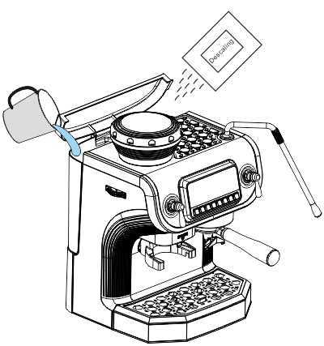

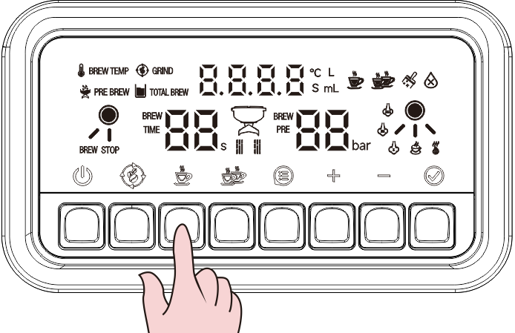
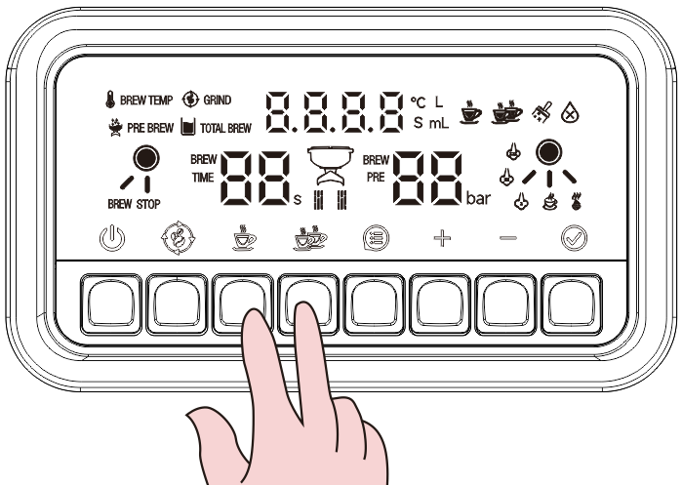
About 1 liter

3 seconds

Chapter VI: Restore factory setting
Restore settings
- In standby mode, press  and  at the same time. The display screen will flash twice to restore factory settings.

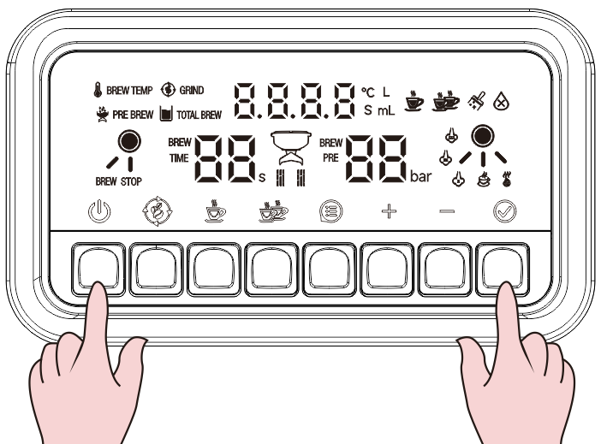

Chapter VII: Cleaning

Cautions:
1. It is prohibited to immerse the coffee maker in water.
2. Make sure to unplug the power cord before cleaning the machine.
3. Do not use strong detergents, sharp objects, brushes, etc. to clean the coffee maker.

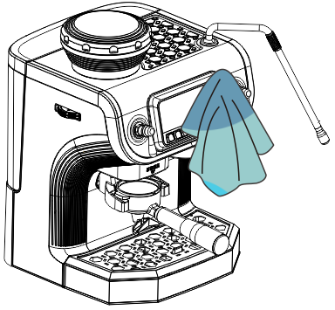

Whole machine cleaning

Parts cleaning
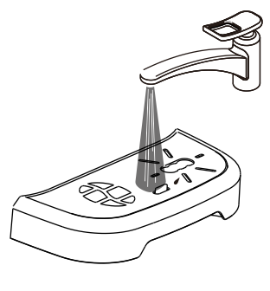
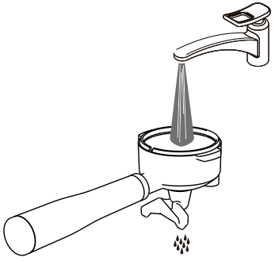
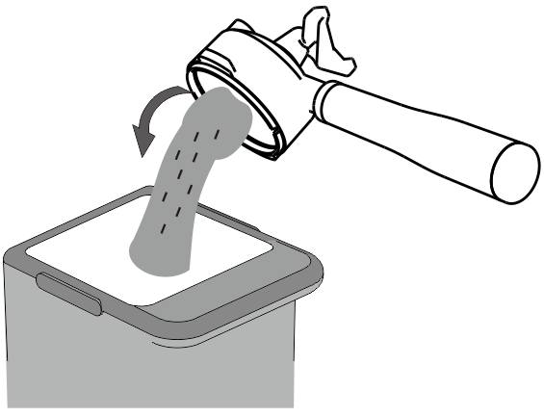

Steam rod cleaning

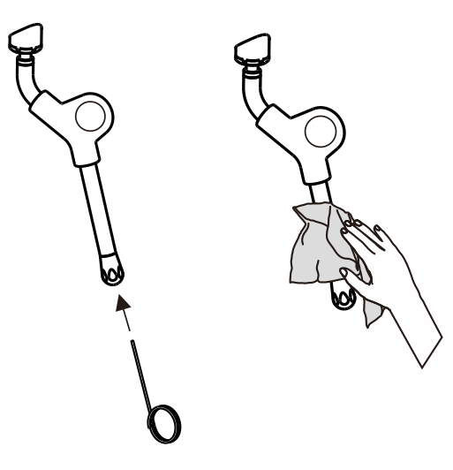

Bean Box Cleaning Please follow the steps below to clean the bean box.
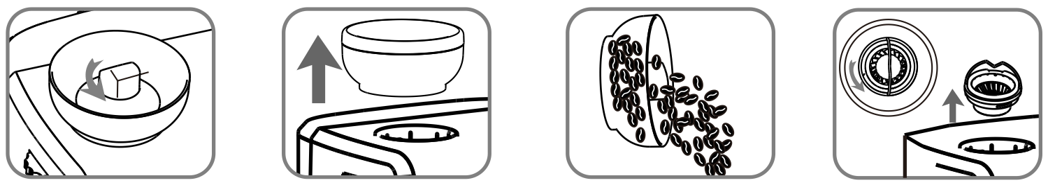

4. Unlock the grinder counterclockwise, then lift it away

3. Pour out excess coffee beans.

2. Remove the bean box.

1. Unlock the bean box.

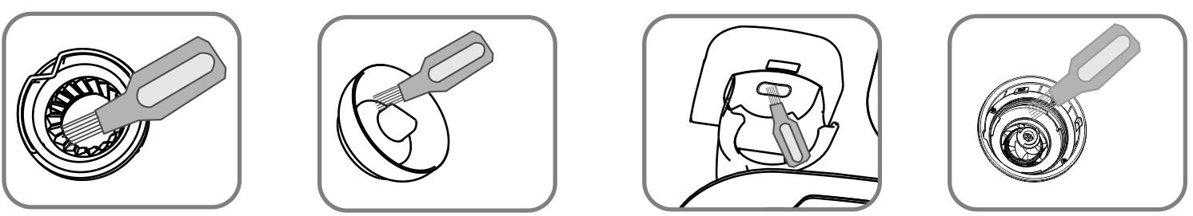

8. Use a brush to clean the grinding knife.

7. Use a brush to clean the powder outlet.

6. Use a brush to clean the bean box.

5. Use a brush to clean the grinder.

Powder Blockage Treatment
The powder outlet may be blocked due to the difference, insufficient drying or improper operation of the user's coffee beans. Clean up as per the following steps

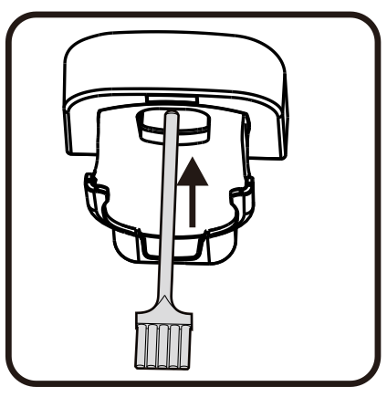

Clean the powder channel with a brush

Chapter VIII: Cautions
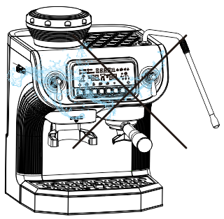

Don’t pour water directly on the machine.

Caution: High Temperature
There is still high-temperature residual heat in the
steam rod after preparing hot water and milk foam.
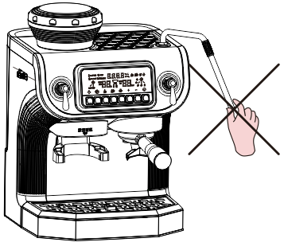

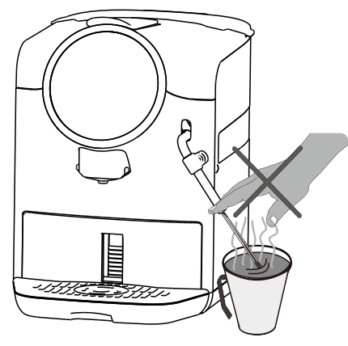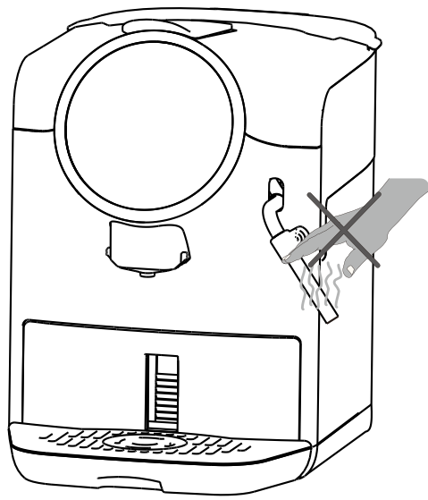

Chapter IX: Solution for Water Pumping Failure

1. The new machine is used for the first time; 2. The machine is not used for a long time; 3. The water tank is lack of water during operating process. There are two solutions to the phenomenon that the machine can't pump out water:

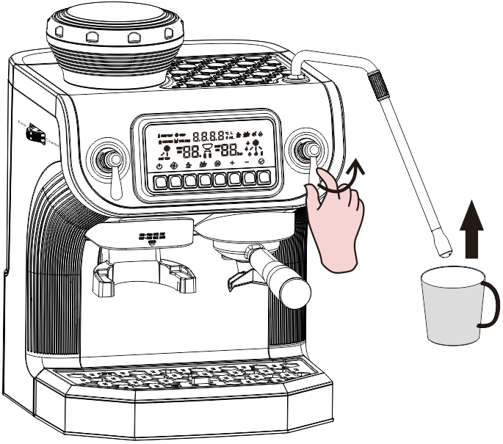
Method 1

1. Put the cup under the steam pipe
2. When the machine is turned on, turn the hot-water lever to the right, and the steam pipe outlet will automatically spray clean water until about 200ML of clean water is discharged

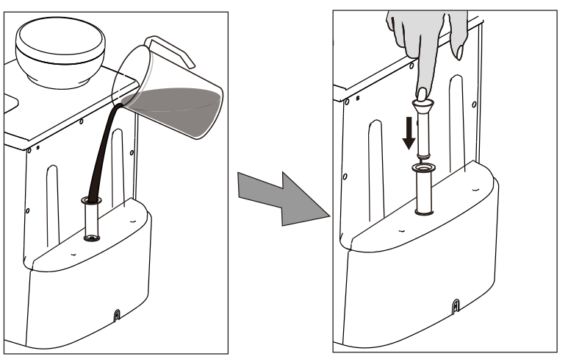

Method 2
Use the "manual pump" in the accessories of the machine to fill the machine with water.

Chapter X: Food Hygiene Label
Food Hygiene Label
Parts Name | Material type | Executive standard | Operating Conditions
Water tank lid\ water tank handle\ knob\ baffle cover\ back plate\ water valve seat\ water valve seat cover\ outlet cover\ top cover panel\ lock pin fixing block\ bracket ornaments | ABS | GB4806.7-2016  GB4806.6-2016
Water tank valve core\ diverter\ bracket\ float\ air pump | PP | GB4806.7-2016  GB4806.6-2016
Limiting plug\ locating seat\ water outlet head\ water outlet head pressure ring\ water pump transition joint\ grinding support\ drive wheel for powder output\ small water pump joint | PA66 | GB4806.7-2016  GB4806.6-2016
Water tank valve O-ring\ sealing gasket for water valve seat\ core connecting pipe\ sealing ring\ back pressure valve\ braided silicone tube\ diverter sealing ring\ silicone tube | Silica gel | GB4806.11-2016
Filtering piece\ filter cup\ spring\ steam pipe\ steam pipe nozzle\ grinding head\ grinding plate\ | SUS304 | GB4806.9-2016
Tee connector\ two-way connector | Aluminum alloy | GB4806.9-2016
Adjustment fixing ring\ upper serrated knife bracket\ lifting platform\ switch ejector pin\ corrector | POM | GB4806.7-2016  GB4806.6-2016


Environmental Protection Use Period of Coffee Maker
Note: All electrical and electronic products sold in China must be marked with environmental protection service life. The environmental protection service life of the sign refers to the service life under normal operation conditions and temperature

Chapter XI: Product Safety Indexes

Product model | ST-530ET
(GS)
230V 50/60Hz
Heating power: 3200W
Grinding power: 150W

